SMART WASTE MANAGEMENT SYSTEM FOR METROPOLITAN CITIES

# TEAM ID : PNT2022TMID08724

# Flow Diagram :

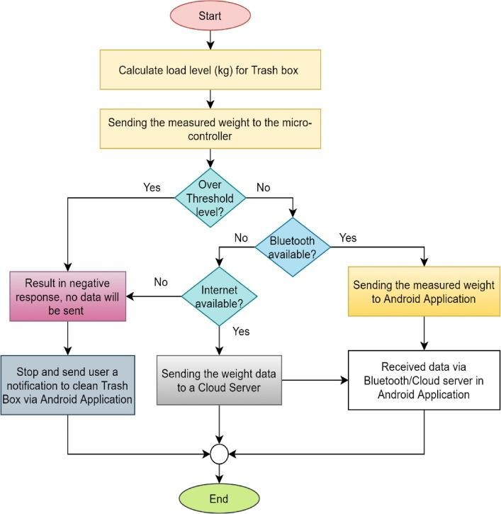

**Data Flow Diagram :**

A Data Flow Diagram is a traditional visual representation of the information flows within a system.A neat and clear Data Flow Diagram can depict the right amount of the system requirement graphically.

It shows how data enters and leaves system, what changes the information and where the data is stored.

A Smart waste management platform uses analytics to translate the data gather in your bins into actionable insights to help you improve your waste services.

You can receive data on metric such as:

* The first test conducted is the situation where the garbage bin is empty or its garbage is very low
* Then, the bin is filled with more garbage until its level has surpassed the first threshold value, which is set to 80% then the first warning to cloud is being sent, as depicted
* The first notification to the cloud by the system is sent, once the waste reaches the level 85%full
* The second notification to cloud is sent by the system, indicating that bin is 95% full and the garbage needs to be collected immediately and the location is sent to the truck driver.
* Location prone to overflow
* The number of bins needed to avoid overflowing waste
* The number of collection Service that could be saved
* The amount of fuel that could be saved
* The driving distance that could be saved

# TEAM ID : PNT2022TMID08724

**TITLE : SMART WASTE MANAGEMENT SYSTEM FOR METROPOLITAN CITIES**